Laser Diodes
Let us first recap on what we covering in lectures 6-8
To make a laser we need to have two things:
1.
2.
To obtain these things we need
1.
2.
If we can achieve sufficient gain to exceed the losses then laser action will be obtained.
For a semiconductor diode, in forward bias we can inject a high density of electrons into the conduction band and a high density of holes into the valence band in the active region of the device. Further we can allow light to bounce back and forth in the material using the Frensnel Reflections from the edges of the device which are carefully cut (cleaved) along particular crystal planes (called facets) [these are normally (110) planes for a GaAs laser where the growth plane is (001).

As for an LED let us first consider a p-n homojunction. In order to give us the best chance of getting an inversion in the active region we will assume both the p- and n-layers to be heavily doped. (p⁺-n⁺ junction). In this circumstance the Fermi-level in the n-type material can be within the conduction band and similarly within the valance band in the p-material.
Under forward bias we inject electrons and holes into the junction region and can create an inversion. The Fermi level splits into two quasi Fermi levels on either side of the junction. Let us consider the probability of finding an electron in the conduction band:
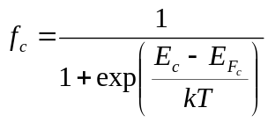
Similar the occupation probability for an electron in the valence band is:
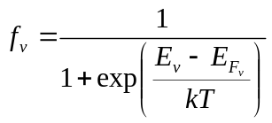
Now (ignoring spontaneous emission) the rate of stimulated emission will be depend on the product (in the same region of space) of the probability of finding an electron in the CB and hole in the VB, which we can write as:
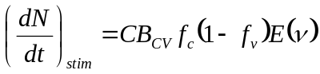
Where 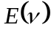 is the energy density of the optical field in the active region of the device, C is a constand and 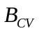 is the Einstein coefficient for the transistion. Similarly the rate of absorption can be written as:
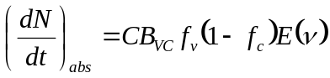
For laser action we need net stimulated emission. i.e. 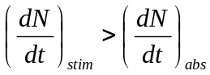
Assuming the transition Einstein coefficients are equal (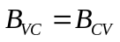) then we have.
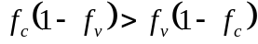 hence 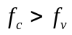
Using the equations for the occupation probability in the CB and VB we obtain:
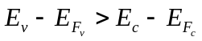
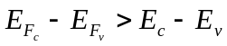
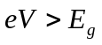
For us to get sufficient inversion to obtain lasing we can expect to need to apply a voltage at least equivalent to the bandgap of the semiconductor.

Homojunction vs Heterojunction Laser Diodes (LDs)
The first homojuction laser diodes were made in 1962, operating at low temperature, although very short pulses of electricity could be used to get such homojunction lasers to operate at room temperature. To get the semiconductor laser to operate continuously at room temperature took until 1970 when the double heterojunction, or heterostructure, (DH) laser was developed. There are two key reasons why such a double heterostructure is needed:
- In a homojunction the carriers can diffuse long way from the junction meaning that much of the recombination could not be confined to the active region of the device, where the photon density allows stimulated emission to dominate.
- We also need to confine the photons to the active region. The homojunction is a poor waveguide, leading to a broad mode, which only a small fraction of which overlaps with the active region. The wings are in the p- and n- GaAs and in this region the absorption can reduce the mode strength.

The double heterostructure gives us barriers in the CB and VB to trap the electrons and holes in the active region, and also provides a strong refractive index difference to give a good waveguide. Furthermore the barriers

Let us consider the manufacture of a 780 nm DH laser diode, which would be made using the techniques described last time. On a n-type GaAs substrate, using MOVPE or MBE, a layer of n-AlGaAs would be grown with a wide bandgap. As AlGaAs has nearly the same lattice parameter (spacing of atoms in the crystal) as GaAs we do not need to worry about strain causing defects. The AlGaAs has an Al content of around 40%. The active region would consist of a thin (few tenths of micron) layer of AlGaAs with a small amount of Al (around 10%) in it. Finally a p-type layer of Al_{0.4}Ga_{0.6}As is grown.
Great care is needed in the next step. The p-contact is defined lithographically and deposited as metal stripes, with a width on the scale of around 10 μm, across the wafer. The stripes are defined to follow exactly along one of the [110] directions on the semiconductor surface.
The sample is then flipped and the back of the wafer thinned and polished to around 100 μm thick (the initial substrate is typically around 350 μm) and then the n-contact placed on the sample. A diamond tip marks the lines on the back where the wafer is to be broken. These may be about 1 mm apart. These lines that the wafer will be broken along will be the [110] directions that are perpendicular to the p-contact stripes. The strips of material will be diced into individual devices and packaged.

There are many ways to improve LDs further, which we will discuss later.

Laser Diode Spectrum
As can be seen from above the semiconductor laser has its emission from the edge, in contrast to the case for the majority of light emitting diodes, where the light is extracted from the top or bottom surface. With a relatively low current density, observing the emission below threshold one obtains a fairly broad spectrum of light over many nanometres.
Increasing the current through the device then eventually we will not just have (population) inversion but the gain in the semiconductor will exceed the losses and the device will begin to lase. The point at which lasing starts is called threshold and the current required is called the threshold current.
At that point a strong narrow peak will occur which will be on one of the allowed laser modes. As we increase the current further it is probable in a simple device that other modes will also start to lase, all using the same pool of electrons and holes in the active region. This “multimode behaviour” is an issue that usually we need to avoid in more advanced LDs.

Laser Diode Gain
Let us look at the absorption and gain spectrum in the material as the laser diode current increases. When no current is applied then for photon energies wavelengths below the active region bandgap we have no absorption. Above the bandgap, being direct, there is strong absorption.
Now as current flows into the device there is emission competing with the absorption process. This only occurs around the bandedge, (or bandgap) we as all the electrons in the conduction band are at the bottom and holes in the VB are at the top of the band. For higher photon energies, corresponding to the energy difference between a state in the middle of the VB to the middle of the CB we still have strong absorption.
This means that near the bandedge the material becomes less absorbing and then there is net gain in the material i.e. the light in the material at a wavelength corresponding to an energy close to the bandgap energy is amplified. As the current increases further the optical gain around the bandgap energy increases until at some point it exceed the threshold value. This is the value where the gain in the material in a photon making one round trip of the cavity exceeds the losses due to scattering in the material and from photons escaping from the light mode, or from the mirror losses. This is the point where lasing can occur. Once the optical gain on one of the allowed cavity modes is high enough, then threshold occurs and laser action will commence.
As the current increases further then other modes can exceed the threshold condition and thus also start lasing this gives the multimode behaviour we described above. Whether multimode or single mode lasing occurs will depend on the width of the gain curve and the spacing of the allowed modes in the semiconductor device.
Let us consider the relative linewidths. As an approximation we can say that the linewidth of LED emission is roughtly the same as the gain linewidth – which for a red LED is somewhere in the region of 30 nm.
From Lecture 8 we had that the wavelength spacing is given by: 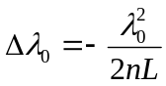
For Red light what are the parameters?
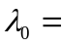
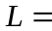
Applying these, gives a value for 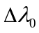 of around 0.05 - 0.3 nm! (Depending on the length of the cavity we chose) This means that under most normal circumstances the mode spacing is much smaller than the gain curve and we can expect multimode behaviour unless we can do something special…..

